Bush Sense

Australian Essential Oils & Aromatic Compounds
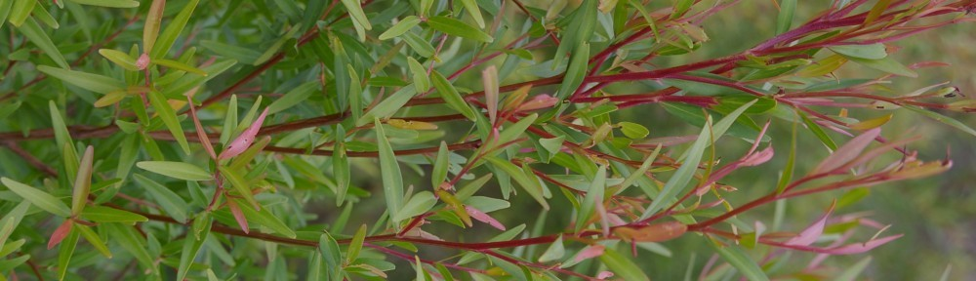

Main menu
Skip to primary content
Skip to secondary content
- Home
- About
- Profiles
- Reviews
- Posts

Blue Cypress & Cypressence
Callitris intratropica Baker and Smith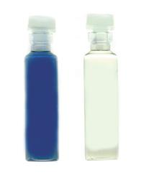
Common Name(s): Northern Australian Cypress Pine
Distribution: Northern Australia, predominantly the Northern Territory. Plantations are with a 80km radius of Darwin NT and on Melville Island.
Description of Plant: A member of the family Cupressaceae (the southern conifers), C. intratropica is a medium to large sized tree (15-45m) with highly fragrant wood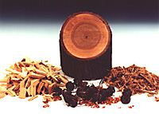.
Parts Used: Wood, Bark, Leaves
Major Chemical Constituents: The chemistry of the essential oil of C. intratropica is quite different to most other available Australian essential oils. When reacted with the naturally-occurring resinous compounds in the bark and cambium, a proportion of guaiazulene can be obtained. This clear, deep cobalt blue oil, known as Australian Blue Cypress Oil, is mostly sesquiterpenoid based and contains as well as guaiazulene: guaiol (20-30%) as its major constituent, with guaienes, selinenes, eudesmols, beta-elemene and several furanones, and has many uses in wound healing, and as an anti-inflammatory and antibacterial.
When the heartwood is distilled by itself, a clear colourless essential oil is obtained which has the same physical and chemical properties as Australian Blue Cypress Oil. Marketed as Cypressence Clear, it has the same therapeutic properties, although lacking the small proportion of guaiazulene.
Constituents of the Bark: The bark and cambium layer are rich in resins, which in earlier years were recovered and used as enteric pill coatings. This material was sold as “Australian Sandarac”. (Lassak and McCarthy). A small proportion of clear, uncoloured essential oil can be distilled from these resinous materials.
Constituents of the Leaves: A turpentine-like essential oil can be distilled from the leaves, its major constituent being l-limonene. This oil is present in only small amounts and is of little aromatic interest.
Therapeutic Properties of Constituents: Anecdotal data, has shown the oil to have good anti-inflammatory and pain-relieving properties against allergic hives, insects (like sandfly, bee, wasp, mosquito), rheumatoid arthritis, general joint pain and swelling. It has also been shown to be an anti-irritant, soothing nappy rash and reducing erythema in a small trial. The oil exhibits anti-viral properties, being particularly effective against common warts (verruca), shingles (herpes zoster) and cold sores (herpes simplex). The oil also has been used for burns where it has significantly reduced the healing time and pain associated with the injury.
Erythema Trial
Small trial ( as prelude to full scale trial), reduction of erythema; erythema induced on forearms of five volunteers by application of standard dose of Peru Balsam applied over area approx. 2cm x 2cm to inner forearm, and patch closed for 4 hours; irritation scores in the mild to moderate (1.5 – 3.5) range recorded. Patches removed, and undiluted Blue Cypress Oil applied randomly to half of the irritated skin at rate of approximately 0.5mls over area. Patches replaced for 4 hours; volunteers checked regularly for signs of discomfort – none found. On removal of patches, the treated areas were found to have reduced signs of erythema, scores falling to minimal range (0 –0.5), with untreated areas relatively unchanged.
Ethnobotany and Historical Use: The Tiwi people of Bathurst and Melville Islands (NT) have used C. intratropica for thousands of years as a skin wash for sores and cuts, to soothe abdominal cramps, as an analgesic and an insect repellent.
Blending: Brilliant fixative properties a wonderous rich base note oil. Blends well with other wood notes as well as citrus and green scents.
Method of Application: Vaporised, bath, massage, perfumery or spot application (neat).
Extraction Method: Steam distillation
Personal experience: Rich, resinous, woody, smoky, honey-like and grounding are words I use to describe Australian Blue Cypress. The Cypressence Clear oil has most of the same traits, but has a slightly softer note, still with the wonderfully scent of the original oil. Both oils are fantastic fixatives in blends, potpourri and perfumery (with Australian Blue Cypress being registered as such).
I have found Australian Blue Cypress oil particularly useful for grounding patients that are flighty, nervous or emotionally distraught. The calming, reassuring effect of this oil is immediate and long lasting, like it scent.

